
Company
Logotype

Cone Beam Computed Tomography- Report



Porur Dental X-rays & CBCT

Patient Name : Mrs. Sumathi | Date of Report : 21.05.2024
Age/ Gender : 53 years/ Female | Region of Interest : CBCT Full Skull
Referring doctor: Dr. S. M. M. Moulvi | Indication : Implant assessment and Root canal assessment
Clinical Notes: Nil
PATIENT INFORMATION

CBCT- Full skull provided
CBCT – IMAGE DETAILS

RADIOGRAPHIC INTERPRETATION

- No of teeth present in the maxillary and mandibular arch: 32.
- Root stumps: 16, 18, 35, 36, 46.
- Hypodense area suggestive of dental caries present in relation to 13, 17, 27, 38, 48.
- In 17, the hypodensity appears to extend involving the pulp canals, with periodontal ligament widening in relation to the mesio- buccal and palatal root.
- In 27, the hypodensity appears to extend involving the pulp canals, with periodontal ligament widening in relation to the mesio- buccal, disto- buccal and palatal root.

IMPLANT ASSESSMENT

 | 16 region
Sub-Crestal (in mm) | 9.3
Mid- Crestal (in mm) | 11.9
Distance between the alveolar ridge and floor of the maxillary sinus (in mm) | 4.7

 | 35 region | 36 region | 46 region
Sub-Crestal (in mm) | 6.2 | 9 | 9.3
Mid- Crestal (in mm) | 7.6 | 11.1 | 11.1
Distance between alveolar ridge and the inferior alveolar nerve canal (in mm) | 11.6 | 11.1 | 14.2
Distance between the alveolar ridge and lower border of mandible (in mm) | 25 | 22 | 25.3

RADIOGRAPHIC IMPRESSION

- Root stumps: 16, 18, 35, 36, 46.
- Dental caries: 13, 17, 27, 38, 48.
- Dental caries with apical periodontitis: 17, 27.

Kindly correlate with clinical findings


IMAGES FOR REFERENCE

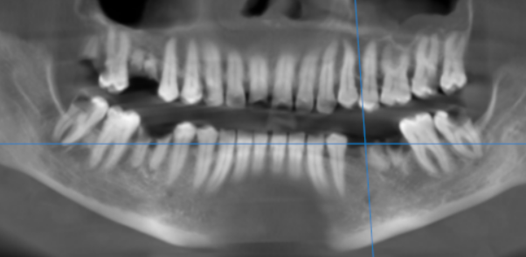

3-DIMENSIONAL VIEW

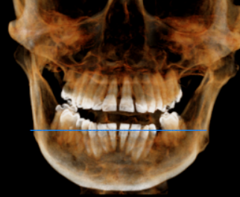

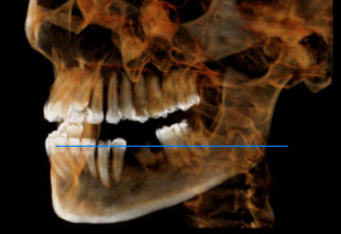

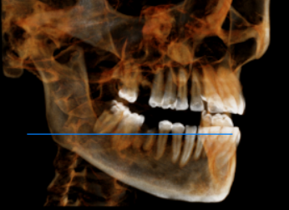

CROSS SECTIONAL VIEW

17 region | 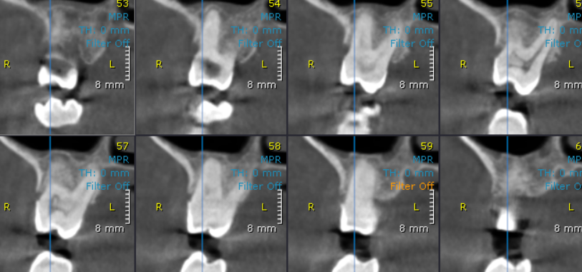
27 region | 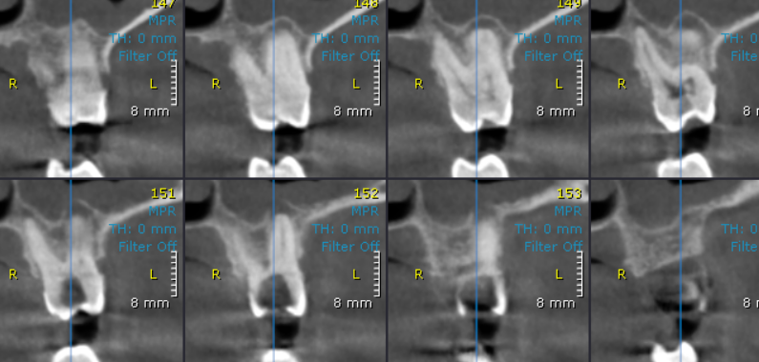

16 region | 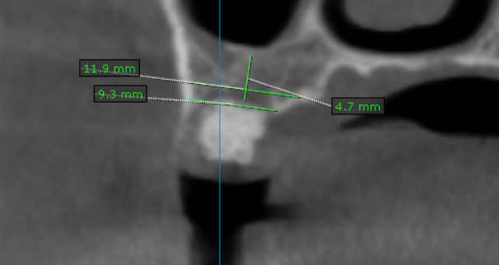
35 region | 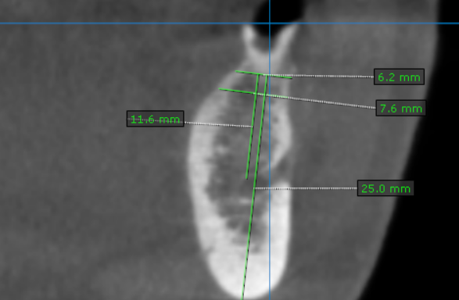
36 region | 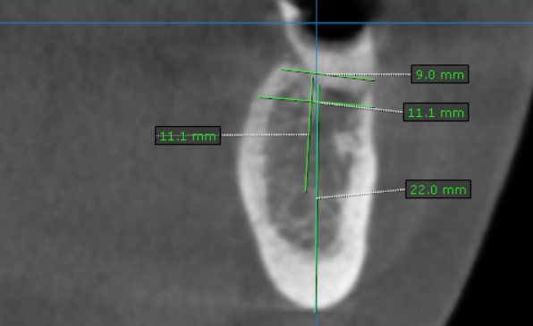
46 region | 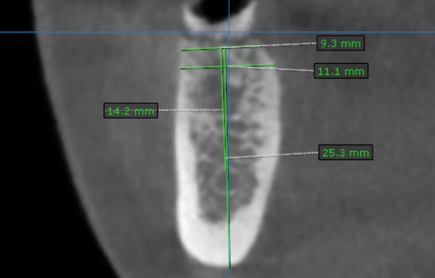

**** End of report ****

